UB Incomers Center

Software Requirements Specification

Version 1.1

November 20th, 2020

Diamond Stuart
Shia Longsworth
Aysha Vaccaro
Shawn Escobar
Lead Software Engineer

Prepared for
Fundamental of Computing
Instructor: Kieran Ryan

Revision History

Date | Description | Author | Comments
November 20th ,2020 | Version 1.1 | Diamond Stuart | First Revision

Document Approval

The following Software Requirements Specification has been accepted and approved by the following:
Signature | Printed Name | Title | Date
 |  | Lead Software Eng.
 | Kieran Ryan | Instructor, CPMS 1134

Table of Contents

Revision History ii
Document Approval ii
1. Introduction 1
1.1 Purpose 1
1.2 Scope 1
1.3 Definitions, Acronyms, and Abbreviations 1
1.4 References 1
2. General Description 2
2.1 Product Perspective 2
2.2 Product Functions 2
2.3 User Characteristics 2
2.4 General Constraints 2
3. Specific Requirements 2
3.1 External Interface Requirements 3
3.1.1 User Interfaces 3
3.1.2 Hardware Interfaces 3
3.1.3 Software Interfaces 3
3.1.4 Communications Interfaces 3
3.6 Inverse Requirements 4
3.7 Design Constraints 4
3.8 Logical Database Requirements 4
4. Analysis Models 4
4.1 Sequence Diagrams 5
4.3 Data Flow Diagrams (DFD) 5
4.2 State-Transition Diagrams (STD) 5
5. Change Management Process 5
A. Appendices 5

1. Introduction
This document contains all the information needed by a software engineer to adequately design and implement the UB Incomers Centre application.

Purpose
The purpose for this SRS is to build an online system to manage the background information of all high schools and the intended audience for which this is written is the teachers at the University of Belize.

Scope
The purpose of the online UB Incomers Centre Application is to ease teachers and to create a convenient and easy to use application for teachers to keep track of all high school information. We will use a database software supporting all high schools in Belize.

Definitions, Acronyms, and Abbreviations
- SQL – is a domain-specific language used in programming and designed for managing data held in a relational database management system, or for stream processing in a relational data stream management system.
- Database – Collection of all information monitored by this system.
- Software Requirements Specification - A document that completely describes all of the functions of a proposed system and the constraints under which it must operate. For example, this document.

References
- https://en.m.wikipedia.org/wiki/SQL

2. General Description
This section of the SRS should describe the general factors that affect 'the product and its requirements. It should be made clear that this section does not state specific requirements; it only makes those requirements easier to understand.

2.1 Product Perspective
This subsection of the SRS puts the product into perspective with other related products or
projects. (See the IEEE Guide to SRS for more details).

2.2 Product Functions
This subsection of the SRS should provide a summary of the functions that the software will perform.

2.3 User Characteristics
This subsection of the SRS should describe those general characteristics of the eventual users of the product that will affect the specific requirements. (See the IEEE Guide to SRS for more details).

2.4 General Constraints
This subsection of the SRS should provide a general description of any other items that will
limit the developer’s options for designing the system. (See the IEEE Guide to SRS for a partial list of possible general constraints).

3. Specific Requirements
This will be the largest and most important section of the SRS. The customer requirements will be embodied within Section 2, but this section will give the D-requirements that are used to guide the project’s software design, implementation, and testing.

Each requirement in this section should be:
- Correct
- Traceable (both forward and backward to prior/future artifacts)
- Unambiguous
- Verifiable (i.e., testable)
- Prioritized (with respect to importance and/or stability)
- Complete
- Consistent
- Uniquely identifiable (usually via numbering like 3.4.5.6)

Attention should be paid to the carefully organize the requirements presented in this section so that they may easily accessed and understood. Furthermore, this SRS is not the software design document, therefore one should avoid the tendency to over-constrain (and therefore design) the software project within this SRS.

3.1 External Interface Requirements

3.1.1 User Interfaces

3.1.2 Hardware Interfaces

3.1.3 Software Interfaces

3.1.4 Communications Interfaces

3.7 Design Constraints
Specify design constrains imposed by other standards, company policies, hardware limitation, etc. that will impact this software project.

3.8 Logical Database Requirements
Will a database be used? If so, what logical requirements exist for data formats, storage capabilities, data retention, data integrity, etc.

4. Analysis Models
List all analysis models used in developing specific requirements previously given in this SRS. Each model should include an introduction and a narrative description. Furthermore, each model should be traceable the SRS’s requirements.

4.1 Sequence Diagrams

4.3 Data Flow Diagrams (DFD)
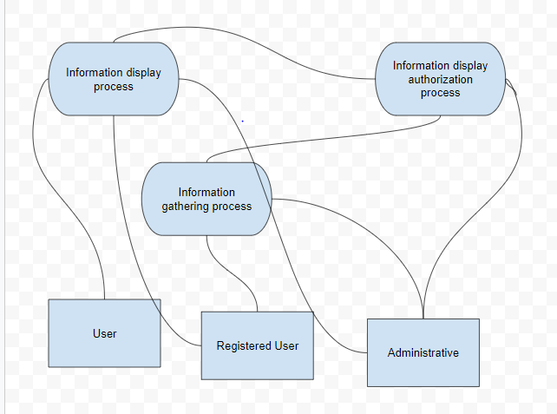

4.2 State-Transition Diagrams (STD)

5. Change Management Process
Identify and describe the process that will be used to update the SRS, as needed, when project scope or requirements change. Who can submit changes and by what means, and how will these changes be approved?

A. Appendices
Appendices may be used to provide additional (and hopefully helpful) information. If present, the SRS should explicitly state whether the information contained within an appendix is to be considered as a part of the SRS’s overall set of requirements.

Example Appendices could include (initial) conceptual documents for the software project, marketing materials, minutes of meetings with the customer(s), etc.

